**MoBot (Motion Controlled Robot)**

**A Project Report**

*Submitted by*

**Eva Khakhkhar**

**Jaydip Gabani**

**Hit Kalariya**

**Manan Trivedi**

***In Partial fulfilment for the award of the degree***

***Of***

**BACHELOR OF ENGINEERING**

*In*

**INFORMATION TECHNOLOGY**



**VALLABH VIDYANAGAR**

**Gujarat Technological University, Ahmedabad**

Academic Year: 2016-2017

**BIRLA VISHWAKARMA MAHAVIDHYALAYA ENGINEERING COLLEGE**

**VALLABH VIDYANAGAR**

**DEPARTMENT OF INFORMATION TECHNOLOGY**

2016-2017



**CERTIFICATE**

This is to certify that the final year project (8th Semester) entitled **“MoBot**” has been carried out by **EVA KHAKHKHAR (130080116012), JAYDIP GABANI (130080116013), HIT KALARIYA (130080116016), MANAN TRIVEDI (130080116027)** under my guidance and supervision for the project work of Bachelor of Engineering in Information Technology (Semester - VII) at BVM Engineering College, Vallabh Vidyanagar during the academic year **2016-17**.

**Date:**

**Guided By: Head of Department:**

**PROFESSOR CHINTAN MAHANT PROFESSOR ZANKHANA H. SHAH**

INFORNATION TECHNOLOGY INFORMATION TECHNOLOGY,

BVM, Vallabh Vidyanagar BVM, Vallabh Vidyanagar

**Plagiarism Report**

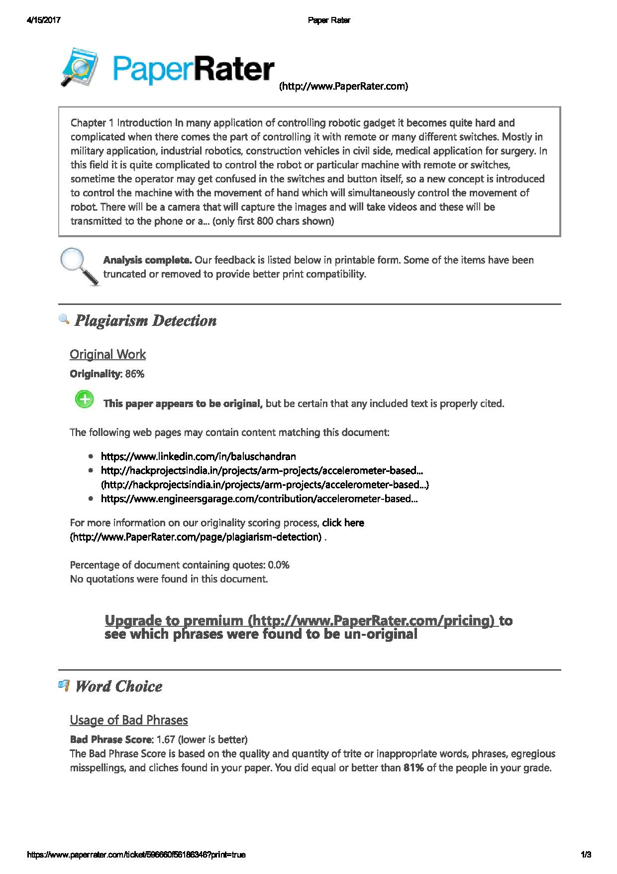

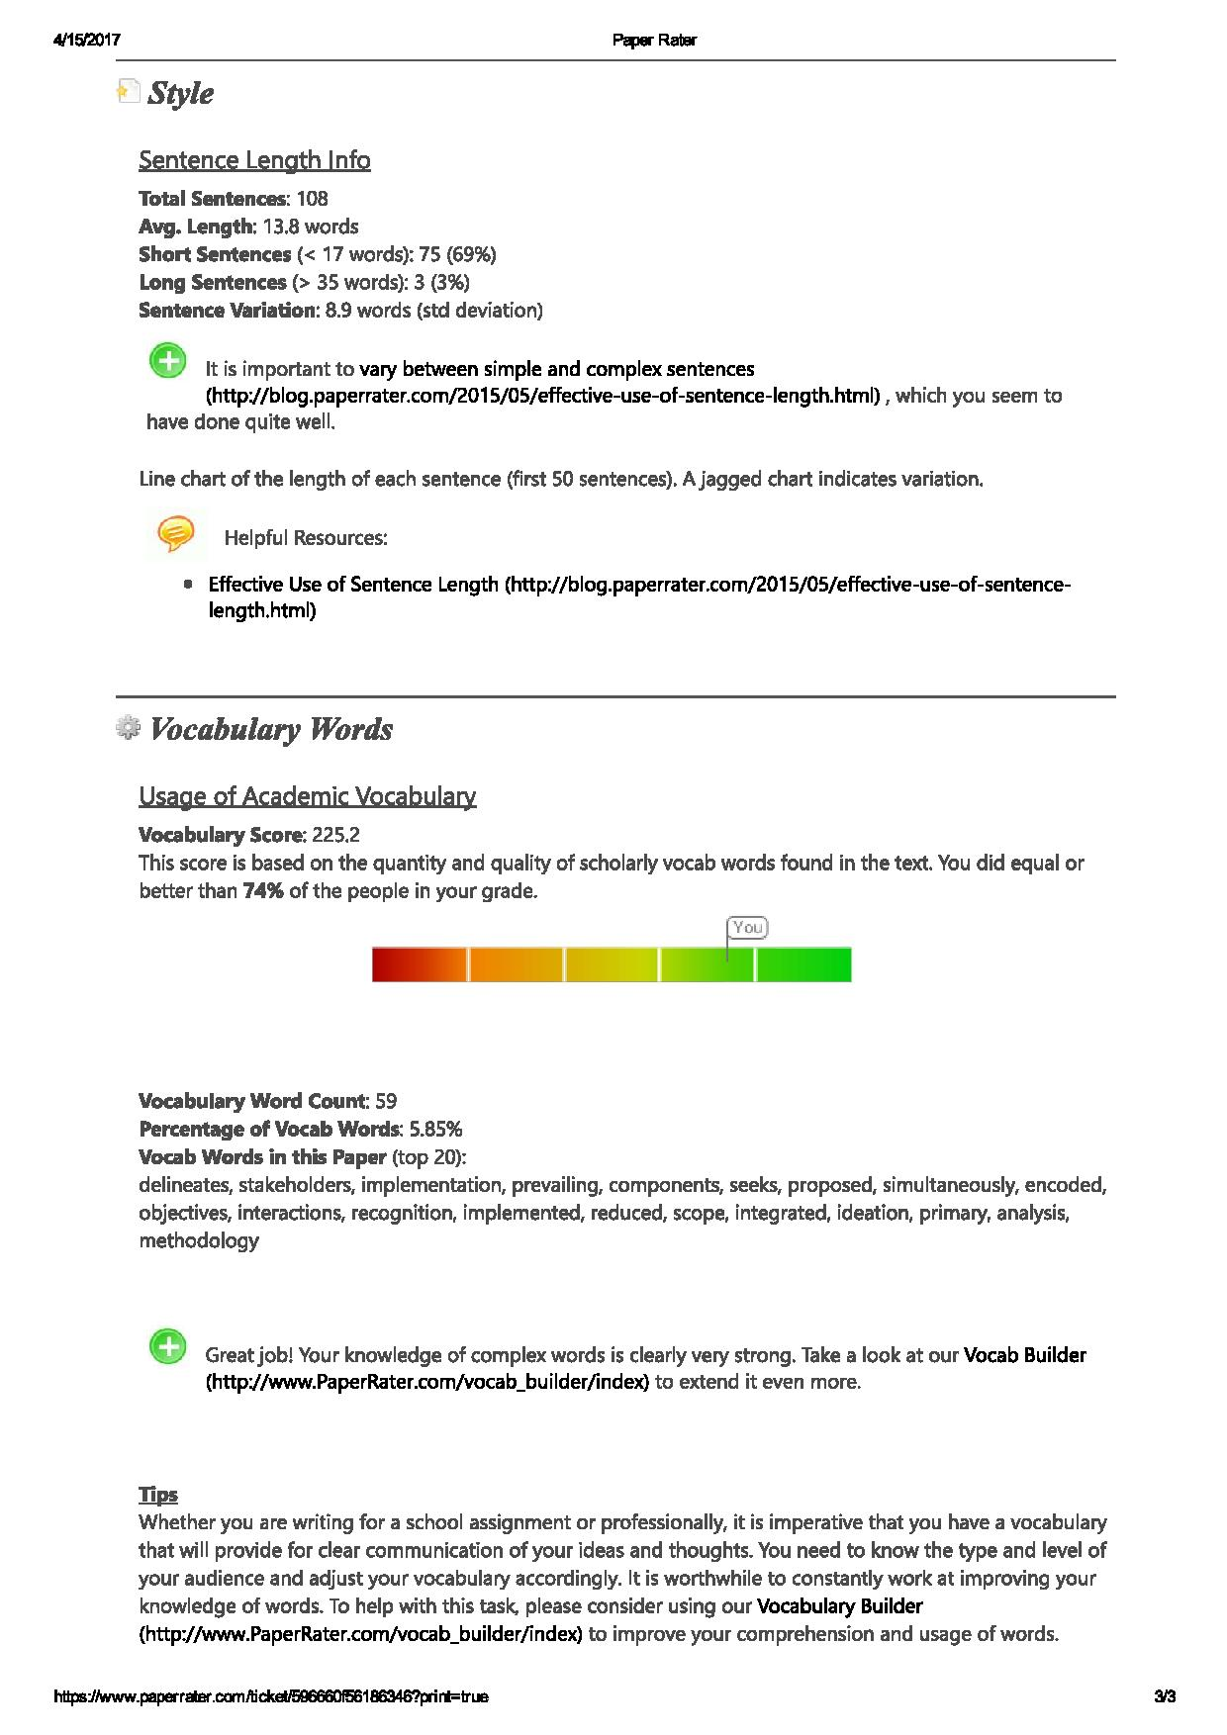

**Certificate of Appreciation**

It gives us pleasure to write this letter of appreciation for

**“MoBot (Motion Controlled Robot)”**

project developed by EVA KHAKHKHAR (130080116012), JAYDIP GABANI (130080116013), HIT KALARIYA (130080116016) & MANAN TRIVEDI (110080116027); students of Information Technology Department, B V M Engineering College, Vallabh Vidyanagar, 2016-2017 batch, guided by the faculty of Information Technology at B V M.

I, as their guide, convey this with pleasure that the project is working truly to our satisfaction. I highly appreciate and acknowledge the efforts of the students in making of this successful project.

I am quite hopeful that these students will continue to demonstrate a similar spirit of excellence, in all their future endeavors’ too. I wish them a highly satisfying and rewarding carrier ahead.

**Prof. CHINTAN MAHANT**

**Project Guide**

UNDERTAKING ABOUT ORIGINALITY OF WORK

We hereby certify that we are the sole authors of this UDP project report and that neither any part of this IDP/UDP project report nor the whole of the UDP Project report has been submitted for a degree by other student(s) to any other University or Institution.

We certify that, to the best of our knowledge, the current UDP Project report does not infringe upon anyone’s copyright nor violate any proprietary rights and that any ideas, techniques, quotations or any other material from the work of other people included in our UDP Project report, published or otherwise, are fully acknowledged in accordance with the standard referencing practices. Furthermore, to the extent that we have included copyrighted material that surpasses the boundary of fair dealing within the meaning of the Indian Copyright (Amendment) Act 2012, we certify that we have obtained a written permission from the copyright owner(s) to include such material(s) in the current UDP Project report and have included copies of such copyright clearances to our appendix.

We have checked the write up of the present UDP Project report using anti-plagiarism database and it is in the allowable limit. In case of any complaints pertaining to plagiarism, we certify that we shall be solely responsible for the same and we understand that as per norms, University can even revoke BE degree conferred upon the student(s) submitting this UDP Project report, in case it is found to be plagiarized.

Team:

|  |  |  |
| --- | --- | --- |
| **Enrolment number** | **Name** | **Signature** |
| 130080116012 | Eva Khakhkhar |  |
| 130080116013 | Jaydip Gabani |  |
| 130080116016 | Hit Kalariya |  |
| 130080116027 | Manan Trivedi |  |

Place: Date:

Name of Guide Signature of Guide

Asst. Prof. Chinatan Mahant

**Acknowledgement**

We express our cavernous sense of obligation and gratitude to our guide **Prof. Chintan Mahant** and his helpful guidance and constant encouragement throughout this project work. We are highly obliged to have him as our honourable guide as he has devoted his valuable time and shared his expertise knowledge.

We thank to **Head of the Department Prof. Zankhana H. Shah**, Department of Information Technology of BVM Engineering College for giving us such an opportunity to do our project work.

#### We are also thankful to our I/C principal **Professor (Doctorate) Indrajit Patel** for his valuable support.

We would like to thank **Information Technology Department of BVM Engineering College** for their support.

We also appreciate to our friends, colleagues and many who have rendered their support for the successful completion of the project, both explicitly and implicitly.

…..

**Eva Khakhkhar 130080116012**

**Jaydip Gabani 130080116013**

**Hit Kalariya 130080116016 Manan Trivedi 130080116027**

**Abstract**

In many application of controlling robotic gadget it becomes quite hard and complicated when there comes the part of controlling it with remote or many different switches.

Mostly in military application, industrial robotics, construction vehicles in civil side, medical application for surgery. In this field it is quite complicated to control the robot or particular machine with remote or switches, sometime the operator may get confused in the switches and button itself, so a new concept is introduced to control the machine with the movement of hand which will simultaneously control the movement of robot. There will be a camera that will capture the images and will take videos and these will be transmitted to the phone or a computer. This will work as live streaming in case of video and will be normal in case of images.

**TABLE OF CONTENTS**

|  |  |  |  |
| --- | --- | --- | --- |
| **CERTIFICATE** | | | **I** |
| **PLAGIARISM REPORT** | | | **II** |
| **CERTIFICATE OF APPRECIATION** | | | **IV** |
| **ORIGINALITY OF WORK** | | | **V** |
| **ACKNOLEDGEMENT** | | | **VI** |
| **ABSTRACT** | | | **VII** |
| **TABLE OF CONTENTS** | | | **VIII** |
| **LIST OF FIGURES** | | | **IX** |
| **Chapter 1** | **Introduction** | | **1** |
|  | 1.1 | Problem Summary | 1 |
|  | 1.2 | Aim of Project | 1 |
|  | 1.3 | Problem Specification | 1 |
|  | 1.4 | Literature Review | 2 |
|  | 1.5 | Plan of Work | 2 |
|  | 1.6 | Materials/Tools Required | 3 |
| **Chapter 2** | **Design : Analysis, Design Methodology and Implementation** | | **4** |
|  | 2.1 | Empathy Canvas | 4 |
|  | 2.2 | Ideation Canvas | 5 |
|  | 2.3 | Product Developments Canvas | 6 |
|  | 2.4 | AEIOU Summary | 7 |
|  | 2.5 | Modules | 8 |
|  | 2.6 | Tools Used | 8 |
|  | 2.7 | Feasibility Study | 11 |
|  | 2.8 | System Flow | 12 |
| **Chapter 3** | **Implementation** | | **15** |
|  | 3.1 | Implementation | 15 |
|  | 3.2 | Flow Diagram | 17 |
|  | 3.3 | Testing and Verification | 17 |
| **Chapter 4** | **Summary of Results** | | **18** |
|  | 4.1 | Summary | 18 |
|  | 4.2 | Future Scope | 18 |
|  | 4.3 | Benchmark of our Project | 18 |
|  | **References** | | **19** |
|  | **Appendix** | | **20** |

**List of Figures**

|  |  |  |
| --- | --- | --- |
| **Figure**  **No.** | **Figure Description** | **Page No.** |
| 1 | Empathy Canvas | 4 |
| 2 | Ideation Canvas | 5 |
| 3 | Product Development Canvas | 6 |
| 4 | AEIOU Summary | 7 |
| 5 | ARDUINO UNO R3 | 8 |
| 6 | HT12E/D | 9 |
| 7 | Motor Driver IC(LM293D) | 10 |
| 8 | Comparator IC(LM324) | 10 |
| 9 | RF Pair | 11 |
| 10 | Accelerometer | 11 |
| 11 | Usecase Diagram | 12 |
| 12 | Sequence Diagram | 13 |
| 13 | Activity Diagram | 14 |
| 14 | Receiver Side | 15 |
| 15 | Transmitter Side | 16 |
| 16 | Flow Diagram | 17 |

**Chapter 1**

**Introduction**

In many application of controlling robotic gadget it becomes quite hard and complicated when there comes the part of controlling it with remote or many different switches.

Mostly in military application, industrial robotics, construction vehicles in civil side, medical application for surgery. In this field it is quite complicated to control the robot or particular machine with remote or switches, sometime the operator may get confused in the switches and button itself, so a new concept is introduced to control the machine with the movement of hand which will simultaneously control the movement of robot. There will be a camera that will capture the images and will take videos and these will be transmitted to the phone or a computer. This will work as live streaming in case of video and will be normal in case of images.

* 1. **Problem Summary**

In this era, humans want machines to do their work instead of themselves. Every one seeks to control their devices with their voice or their gesture/hand movements. So we have decided to control our car type robot with the hand movements which will be useful to analyse the areas that can’t be reached by the humans themselves. This can be used for getting visual of any place without actually going to the site. And controlling robot is also easy because there are less connection and it is controlled by the hand movements.

* 1. **Aim and Objectives**

Aim of our project is to control the car type robot using hand movements and get the live streaming of the situation without going to the place in real. The robot can be used for getting sight of the place where radiations are scattered, in the situation of the earthquake, spying purpose, etc.

* 1. **Problem Specification**

There are major problems with the interactions to machines. Main problem is complex circuit with machines if it is having wired connection. We have reduced wired connection by transmitting the data over RF transmitter and receiving the same with RF receiver. We are getting the live streaming over the IP address of the camera so that is also wireless connection with the camera.

* 1. **Literature Review and Prior Art Search**
* **Getting Started with Arduino – Massimo Banzi**

The book is written by the cofounder of Arduino, Massimo Banzi. He has worked for several famous companies like Whirlpool, Prada, and Adidas. He has also worked as a software architect for companies like Italia Online, BT, MCI WorldCom, and Storagetek.

* **Introduction to Robotics: Mechanics and Control**

John J. Craig is the author of this book giving knowledge of the robotics.

* **Robot building for beginners**

David Cook has written this book giving the advice to the rookie students of robotics.

* [**User Guide | Arduino Based Camera**](http://www.arducam.com/category/user-guide/)

This is user guide for the camera connection and programming for getting the output.

* **Real-time robotic hand control using hand gestures**

Jagdish lal Raheja, Radhey Shyam, G. Arun Rajsekhar

* 1. **Plan of Work**

Project Plan

* 1. **Materials/ Tools Required**
* Accelerometer
* ArduCam
* Arduino Board
* Arduino IDE
* Arduino WiFi Shield/Bluetooth
* Batteries
* Body
* Bread Board
* Cables
* Comparator IC
* HT12D/E
* Motor Driver IC(L293D)
* Motors
* Open C
* Phone/PC
* RF pair

**Chapter 2**

**Design: Analysis, Design Methodology and Implementation Strategy**

**2.1 Empathy Canvas**

Empathy canvas includes discovering and learning about the emotional aspects of the user. This helps us in gaining the knowledge about the user and the activities they perform. Our primary users include military organizations, detective agencies and radioactive scientists. The stakeholders are families, friends and funding organizations. The activities performed by them will be controlling the robot and capturing the images and videos.

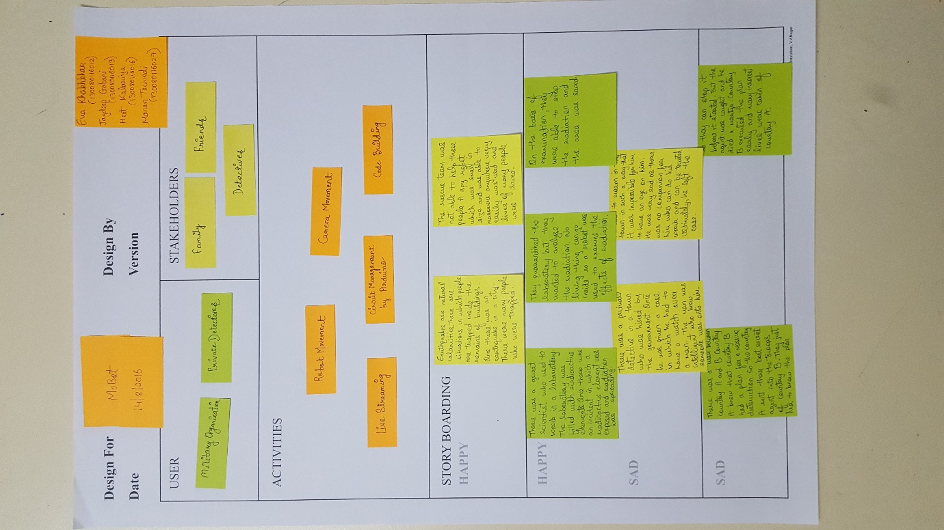

Figure 1

**2.2 Ideation Canvas**

Here we will focus on expanding the list of user activities to list all possible new situations, conditions that users face or may face. It delineates the link between users and activities and the situations related to it. It portraits a clear picture of how our users will be using out product. The props used are Arduino board, RF transmitter and receiver, accelerometer and Arduino IDE.

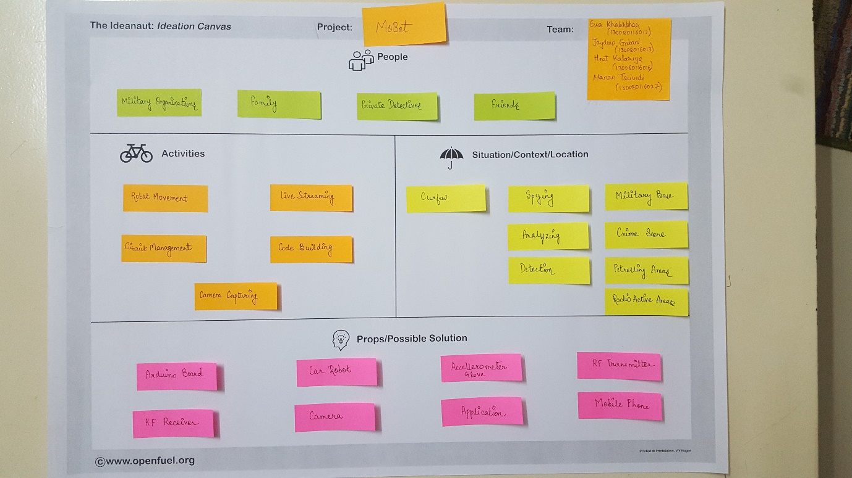

Figure 2

**2.3 Product Development Canvas:**

This canvas will require us to start building a structure of our project around the emotional needs of our users. The solutions depicted will be related to the emotional needs of our users and that will be the core of our solutions. We make a list of the features and functions of our product. Functions are actions of our product and features are those entities which support functions of users. The user will be able to manage the movements of the robot with the help of accelerometer attached to the hand of the user.

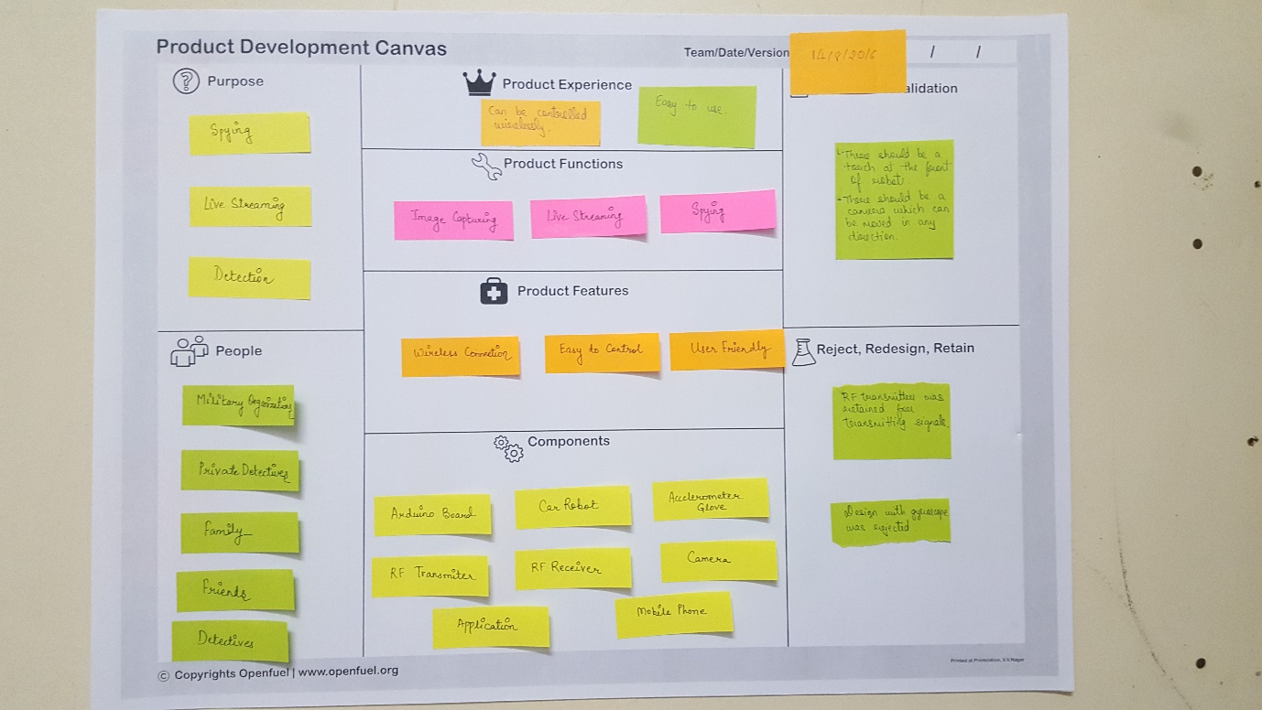

Figure 3

**2.4 AEIOU Summary**

AEIOU is a heuristic which helps us to interpret the observations gathered. The primary functions will be to ultimately address the objectives and issues of the client.

The activities include the movements of the robot once the code is built. Other activities include capturing the images, live streaming and the movement of the camera. The environment includes the working of our robot in different conditions. The interaction includes the communication of robot with the user. Objects define the modules that will be needed to interact with the system like Arduino board, accelerometer, RF transmitter, RF receiver, Arduino IDE.

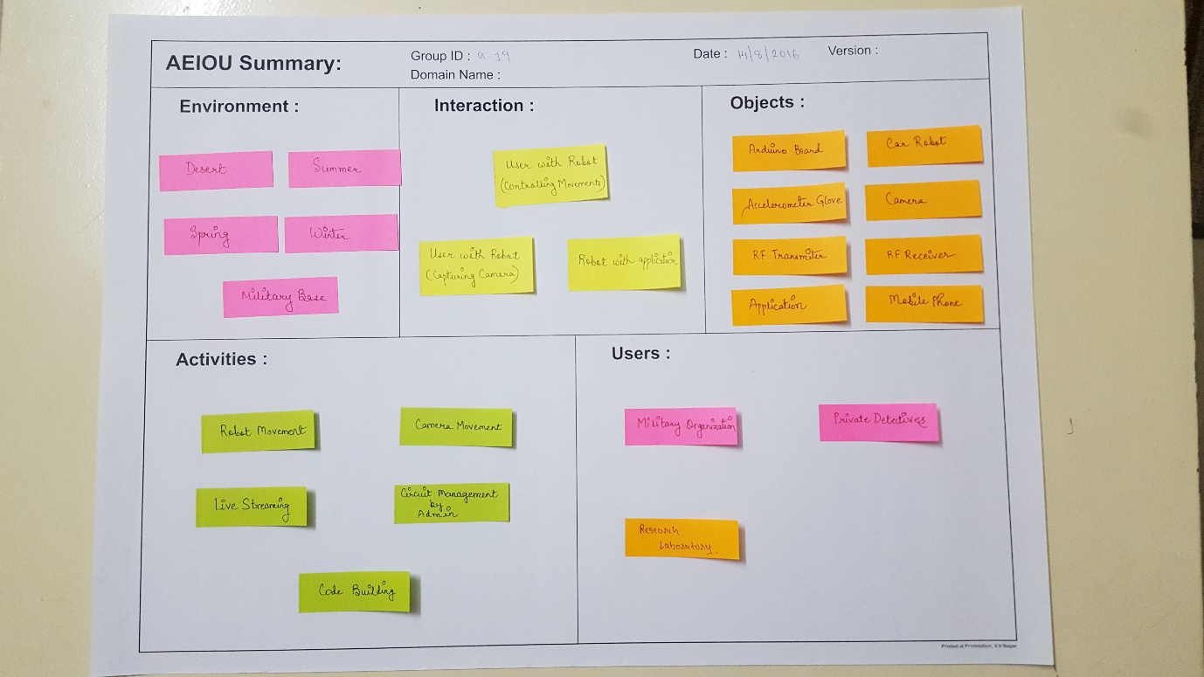

Figure 4

**2.5 Business Model Canvas**

Business model canvas is approach to finding out the difficulties in selling of product that is developed.

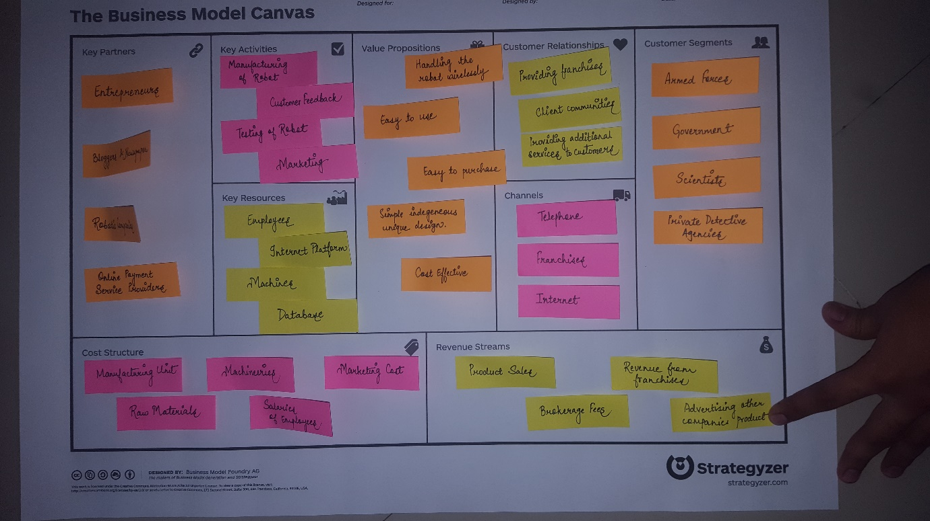

Figure 5

* 1. **Modules**

1. Connection of transmitter and receiver part.
2. Construction of robot body.
3. Programming of robotic movements in the Arduino board: Left, Right, Front, Back.
4. Spy camera: Camera movements, capturing images
5. Live streaming of camera.

**2.5.1 Modules implemented in this semester**

1. Connection of transmitter and receiver part.
2. Construction of robot body.
3. Programming of robotic movements in the Arduino board: Left, Right, Front, Back.
   1. **Tools Used**
      1. **ARDUINO UNO R3**

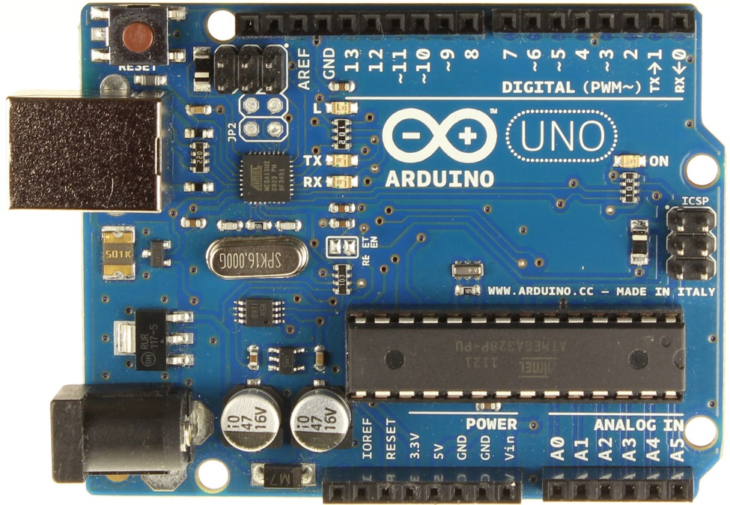

Figure 6

ARDUINO UNO R3 is a microcontroller board based on the ATmega328P. It has 14 digital input/output pins (of which 6 can be used as PWM outputs), 6 analog inputs, a 16 MHz quartz crystal, a USB connection, a power jack, an ICSP header and a reset button. It contains everything needed to support the microcontroller; simply connect it to a computer with a USB cable or power it with a AC-to-DC adapter or battery to get started.

* + 1. **ARDUINO IDE**

It is used to program ARDUINO board for various purposes. It provides code development environment and provides way to run and upload code to Arduino which is quite easy for the beginners. It provides various sample code. It  runs on Windows, Mac OS X, and Linux. The environment is written in Java and based on Processing and other open-source software. This software can be used with any ARDUINO board.

* + 1. **HT12E/D**

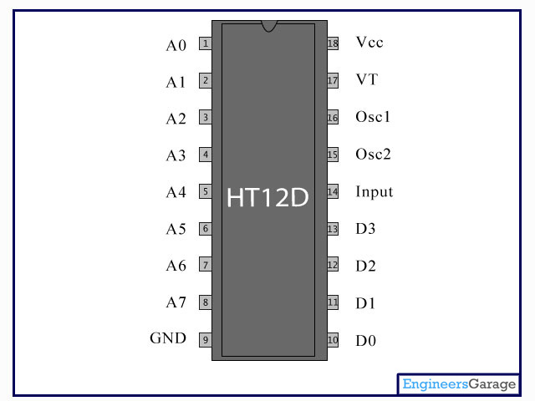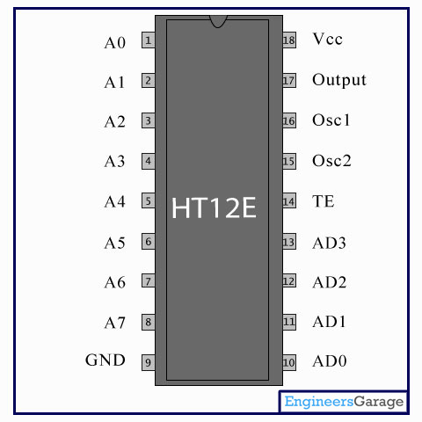

Figure 7

**HT12D** is a **decoder integrated circuit** that belongs to 212series of decoders. This series of decoders are mainly used for remote control system applications, like burglar alarm, car door controller, security system etc. It is mainly provided to interface RF and infrared circuits.  They are paired with 212 series of encoders. HT12D is capable of decoding 12 bits, of which 8 are address bits and 4 are data bits. The data on 4 bit latch type output pins remain unchanged until new is received.

**HT12E** is an **encoder integrated circuit** of 212series of encoders. They are paired with 212 series of decoders for use in remote control system applications. It is mainly used in interfacing RF and infrared circuits. The chosen pair of encoder/decoder should have same number of addresses and data format.HT12E converts the parallel inputs into serial output. It encodes the 12 bit parallel data into serial for transmission through an RF transmitter. These 12 bits are divided into 8 address bits and 4 data bits.

* + 1. **Motor Driver IC(L293D)**

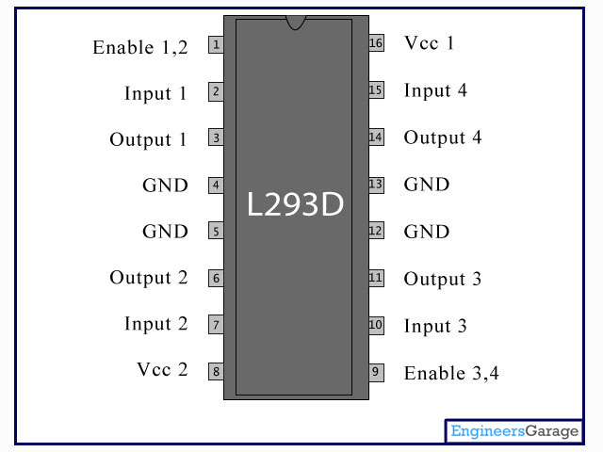

Figure 8

Motor Driver IC(L293D) is used to drive DC motors either way. It is 16-pin IC capable of controlling two DC motors simultaneously in any direction. It operates on +5V.

* + 1. **Comparator I(LM324)**

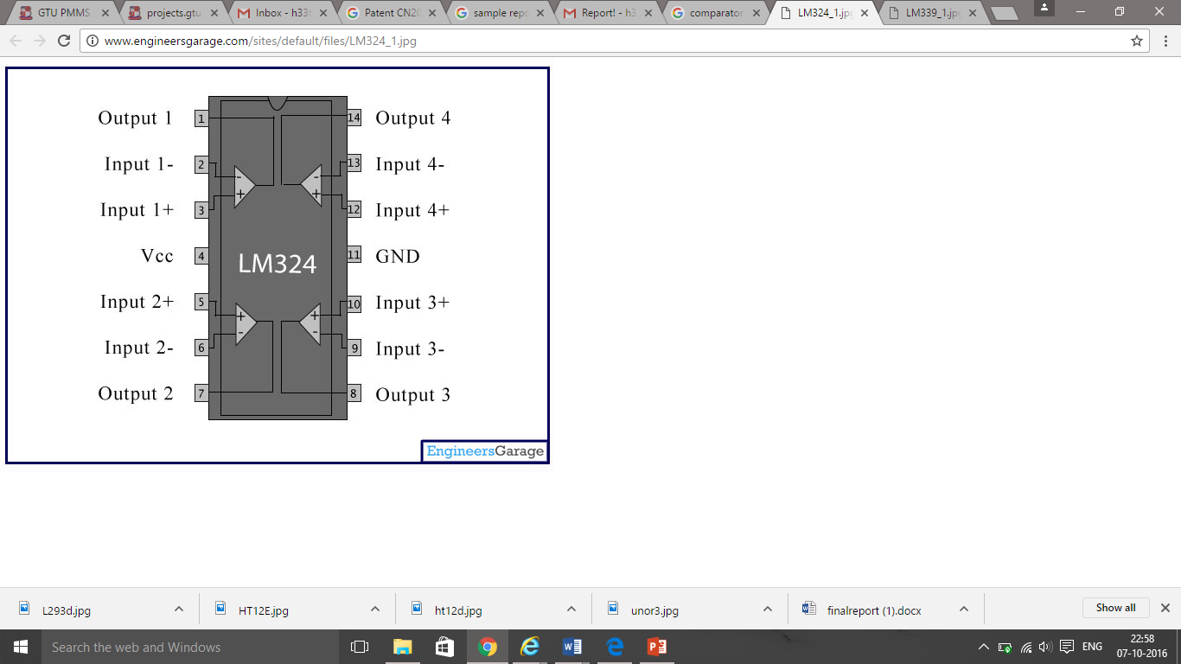

Figure 9

**LM324** is a 14pin IC consisting of four independent operational amplifiers (op-amps) compensated in a single package. Op-amps are high gainelectronic voltage amplifier with differential input and, usually, a single-ended output. The output voltage is many times higher than the voltage difference between input terminals of an op-amp.

* + 1. **RF Pair**

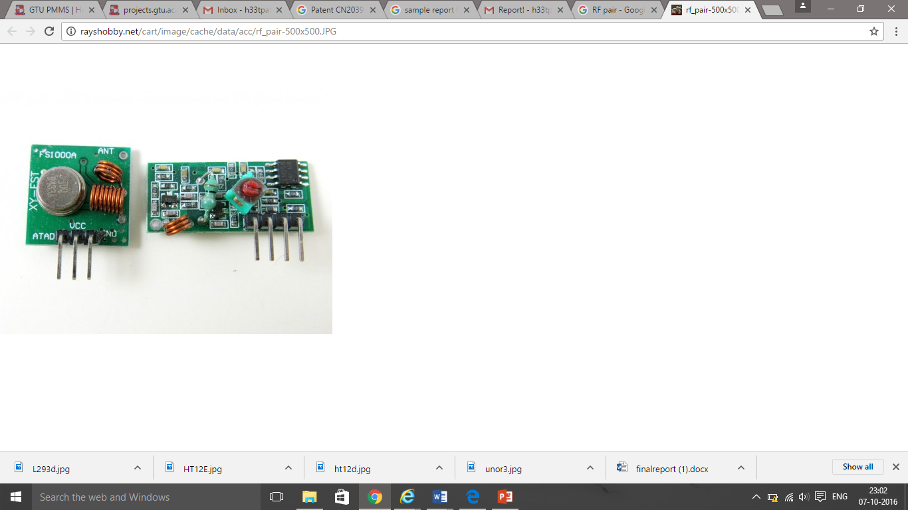

Figure 10

**RF pair** is able to transmit data over 100 meters range. It is available in two frequencies, 315MHz and **434MHz**. Transmitter is able to operate in a wide voltage range, 3 – 12V making it ideal for battery powered applications.

* + 1. **Accelerometer(ADXL345)**

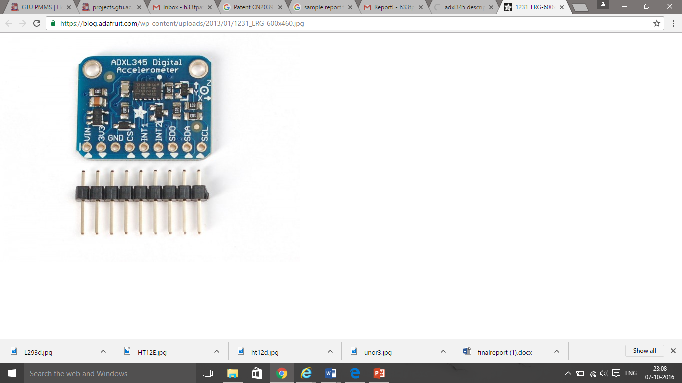

Figure 11

The **ADXL345** is a small, thin, ultra low power, 3-axis accelerometer with high resolution (13-bit) measurement up to ±16 g. Digital output data is formatted as 16-bit twos complement and is accessible through either a SPI (3- or 4- wire) or I2C digital interface. It measures the static acceleration of gravity in tilt-sensing applications, as well as dynamic acceleration resulting from motion or shock. Its high resolution (4mg/LSB) enables resolution of inclination changes of as little as 0.25°.

* + 1. **NC 200 TP-LINK Camera**

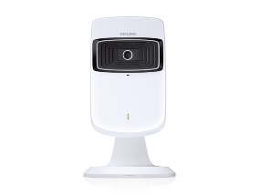

Figure 12

NC200 can be accessed remotely, and controlled from any computer over your local network or through the Internet via a web browser.NC200 is a cloud-based Wi-Fi video monitoring device with free live streaming and remote viewing, which makes it easy to stay connected with what you care most wherever you are. You can view and manage your camera from anywhere over the Internet.

Features of Nc200:

* Supports wireless 802.11b/g/n with speed up to 300Mbps
* Wireless connectivity compliant with WPS button
* Instantly eliminates the dead zones and expand your home’s wireless network
* Ethernet port for wired connectivity
* UPnP support for network setup & configuration
* 4x digital zoom for close-up viewing

* + 1. **Android Studio**

Android Studio is the official [integrated development environment](https://en.wikipedia.org/wiki/Integrated_development_environment) (IDE) for the [Android](https://en.wikipedia.org/wiki/Android_(operating_system)) platform.

Features:

* [Gradle](https://en.wikipedia.org/wiki/Gradle)-based build support
* Android-specific [refactoring](https://en.wikipedia.org/wiki/Code_refactoring) and quick fixes
* [Lint](https://en.wikipedia.org/wiki/Lint_(software)) tools to catch performance, usability, version compatibility and other problems
* [ProGuard](https://en.wikipedia.org/wiki/ProGuard_(software)) integration and app-signing capabilities
* Template-based wizards to create common Android designs and components
* A rich [layout editor](https://en.wikipedia.org/wiki/Graphical_user_interface_builder) that allows users to drag-and-drop UI components, option to [preview layouts](https://en.wikipedia.org/wiki/WYSIWYG) on multiple screen configurations[[13]](https://en.wikipedia.org/wiki/Android_Studio#cite_note-13)
* Support for building [Android Wear](https://en.wikipedia.org/wiki/Android_Wear) apps
* Built-in support for Google Cloud Platform, enabling integration with Firebase Cloud Messaging (Earlier 'Google Cloud Messaging') and Google App Engine[[14]](https://en.wikipedia.org/wiki/Android_Studio#cite_note-14)
* Android Virtual Device (Emulator) to run and debug apps
  1. **Feasibility Study**
     1. **Technical Feasibility**
* This system is very user friendly because it doesn’t require wired connection.
* No need to give command from remote or phone application as it is motion controlled it will consume less time.
  + 1. **Economical Feasibility**
* This system is also economically feasible because it is having low circuit maintenance and low cost hardware parts.
  + 1. **Operational Feasibility**
* Robot system is having fiber/metal body so in any weather condition it is having ability to perform very well.
  + 1. **Schedule Feasibility**
* Our project will be completed before 12 months as we are having basic knowledge of circuit and code that is used for it.
  1. **SYSTEM FLOW**
     1. **USE CASE DIAGRAM**

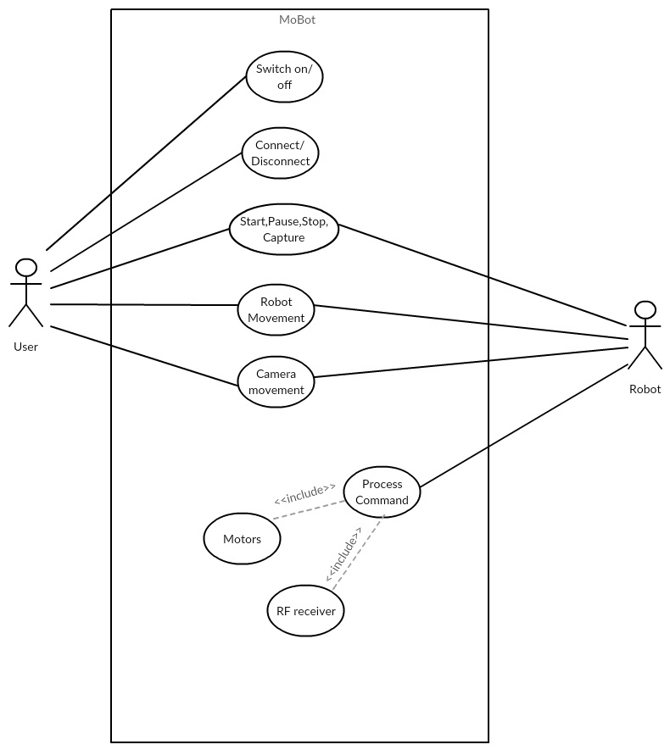

Figure 13

* + 1. **SEQUENCE DIAGRAM**

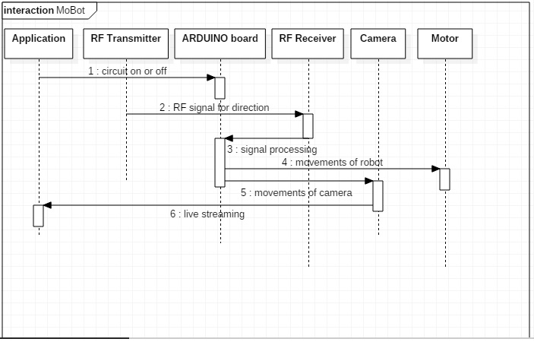

Figure 14

* + 1. **ACTIVITY DIAGRAM**

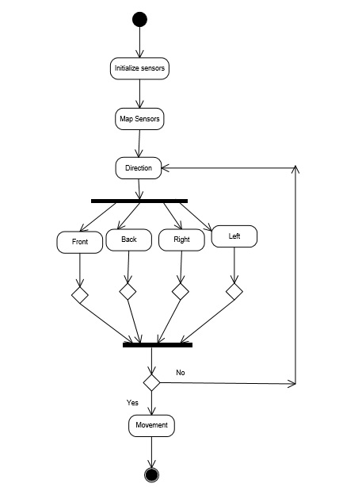

Figure 15

**Chapter 3**

**Implementation**

* 1. **Implementation**

We have implemented the circuit of the robot as per the diagram. There are two components in the circuit like Receiver side and Transmitter side. There is separate connection for both the side. We connected the accelerometer and RF transmitter on the Transmitter side. In that part reading from the accelerometer is taken and converted to the digital signal and it is encoded using HT12E. Then signals are transmitted to the Receiver side. Now, at the receiver side these signals are decoded using HT12D and then reading is transferred to the ARDUINO board. Now according to the ARDUINO program signals to the motors are generated as per the input. Motors are driven by the motor-driver IC(LM293D).

**Receiver Side:**

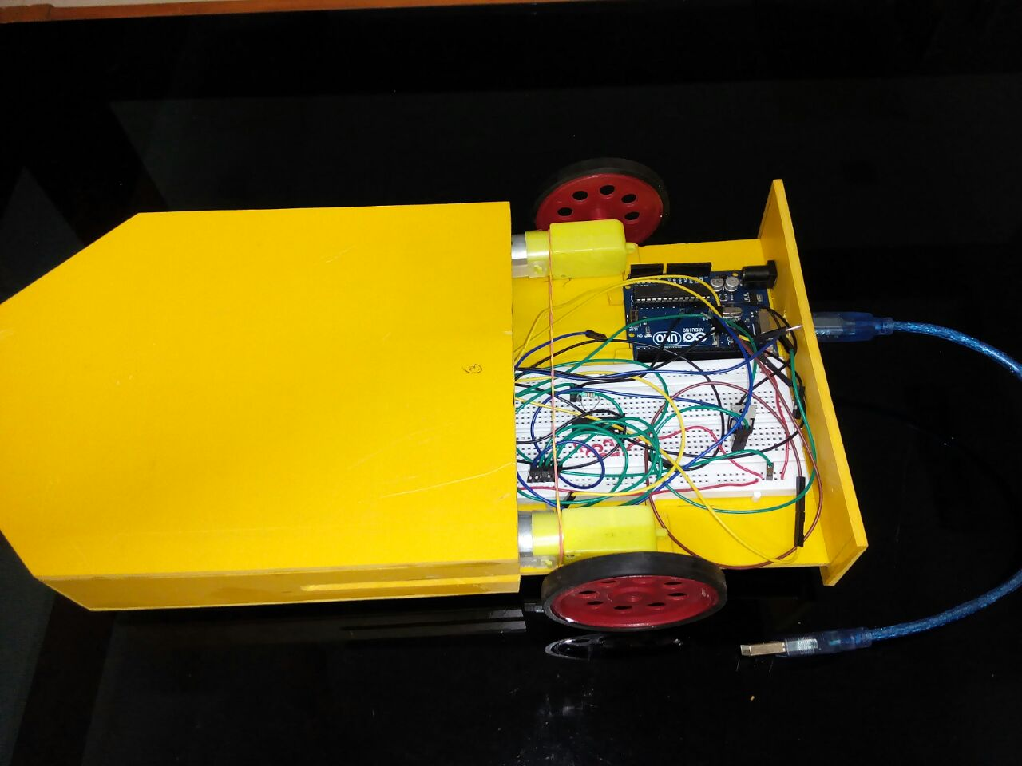

Figure 16

**Transmitter Side:**

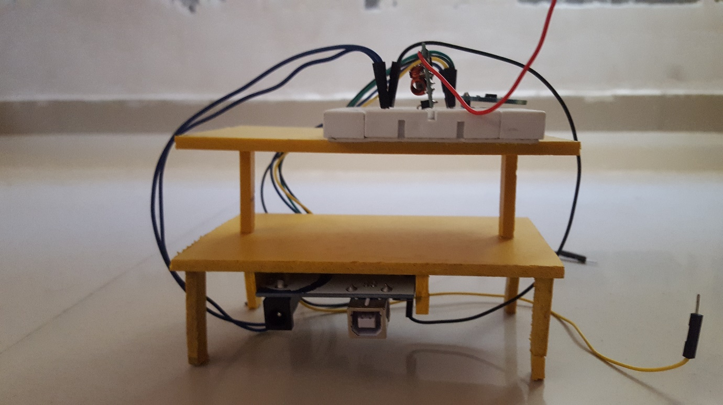

Figure 17

* 1. **Flow Diagram**

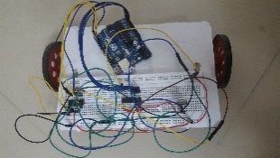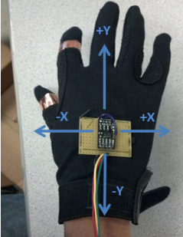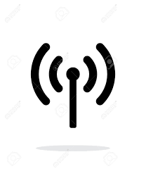

Figure 18

* 1. **Testing and Verification**
* We tested accelerometer for the correct output of x/y axis by connecting it to the ARDUINO board directly.
* We tested each IC.
* Then we programmed ARDUINO board and tasted the robot movements according to it.

**Chapter 4**

**Summary of Results**

**4.1 Summary**

Many technologies are developing day by day and one such promising concept is human-machine interface. With the help of prevailing science and technology, we have developed a human-machine interaction system in the form of a compact robot. This novel application involves interaction between humans and robot where the robot must coordinate with their human owners. The proposed technology will depend on gesture recognition technology. The system involves use of a camera for spying purposes that can be used for military purposes. The system is user friendly as it does not require any prior knowledge to use it.

**4.2 Future Scope**

The system that is portrayed here is a preliminary example of what can be done with it. There is a huge scope of improvement in the existing project. This is a compact robot that may face problems during the manoeuvrability. We will try to make it better so that it moves freely on any terrain and does not have any problems going through rough roads. A thermal sensor can also be integrated with the system that can be helpful for military purposes to detect the movements of enemies. An extremely sensitive thermal sensor can detect the movement of human body. The robot can be both be used for spying and the thermal sensor can detect the presence of enemies if they camouflage themselves and cannot be recognized through camera.

**4.3 Benchmark of our Project**

Along with the minuscule size of our system, it can also be used to scout any person without that person knowing and can be used to capture the movements. The military can also use it with the thermal detectors to have an eye on the enemies. A smooth synchronization between the system and user makes it easy to use. It can also be used to access different areas of forests where people can’t possibly go.

**References**

[1] [www.circuitdigest.com](http://www.circuitdigest.com) (Circuit Digest website).

Referred this website for the circuit connection of receiver as well as transmitter side.

[2] [www.wikipedia.org](http://www.wikipedia.org)

We have referred the Wikipedia for the reference of the robotics field. We have read many articles regarding the robotics that gave us the valuable information about this field.

[3] [www.arduino.cc](http://www.arduino.cc)

We have referred this website for the programming of ARDUINO board. We have downloaded the IDE from this website and learned many tutorials from this website.

[4] [www.youtube.com](http://www.youtube.com)

We watched many videos from the youtube regarding our project

[5] developer.android.com

We have learned android topics from this website.

PPR 1: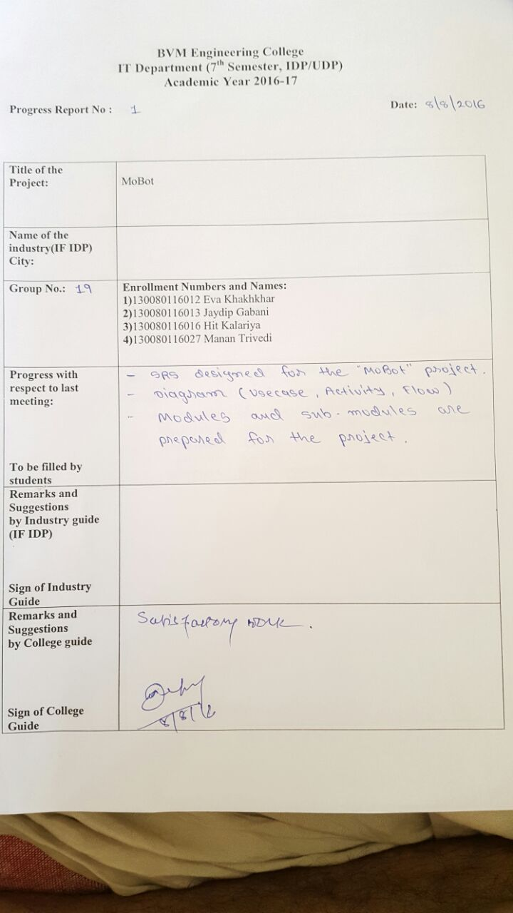

PPR 2:

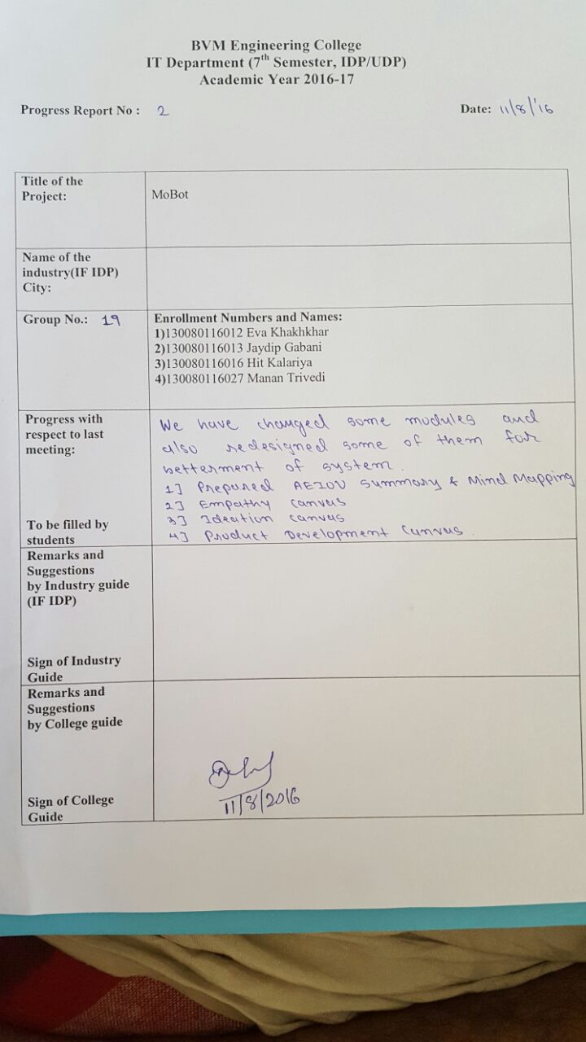

PPR3:

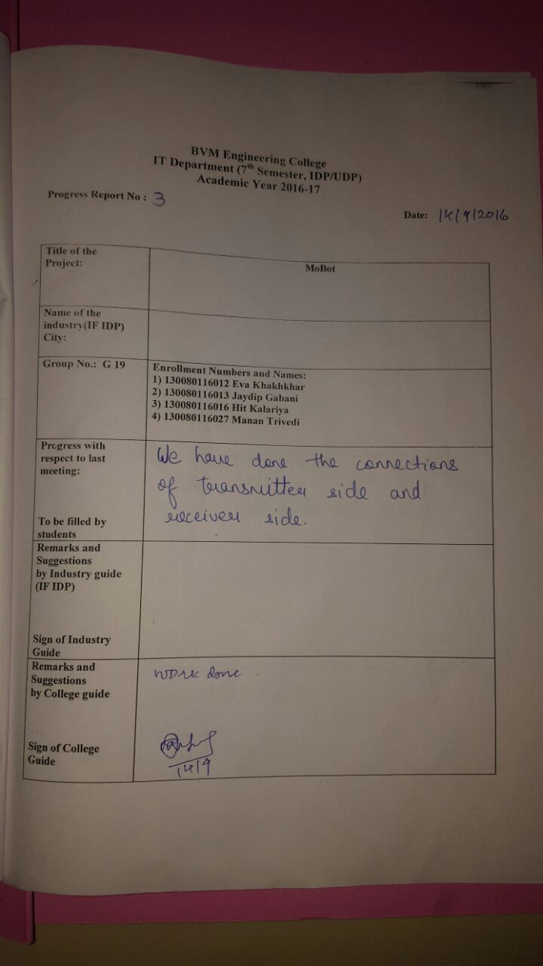

PPR 4:

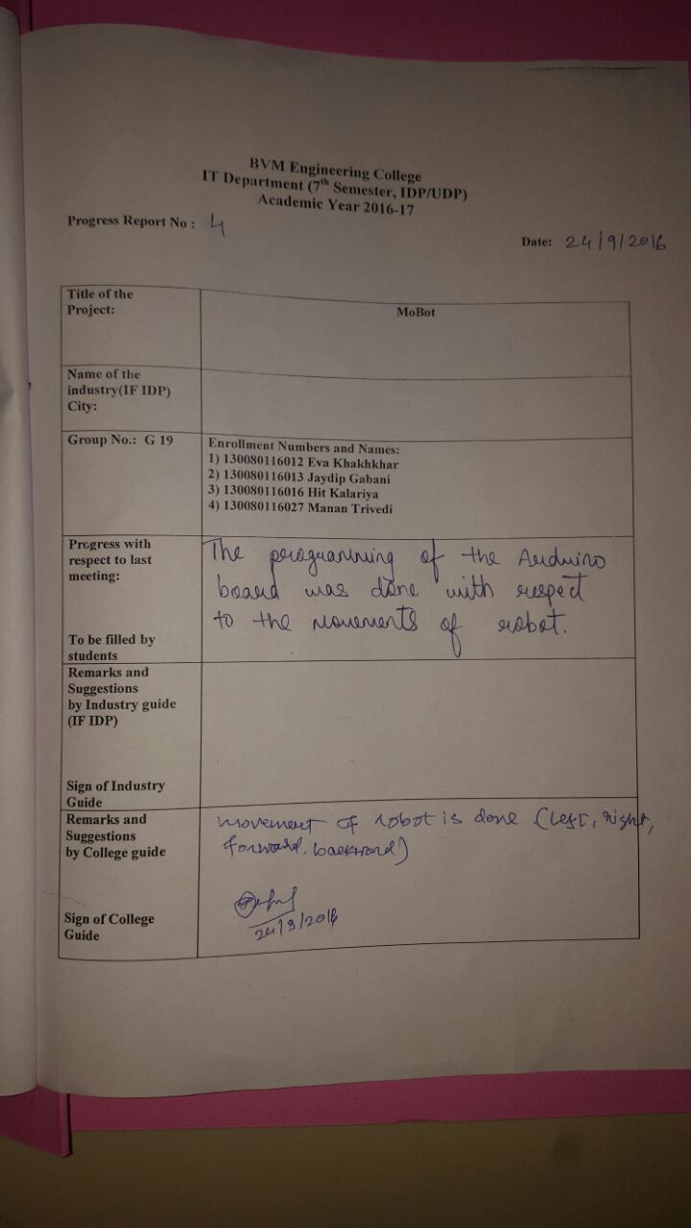

PPR 5:

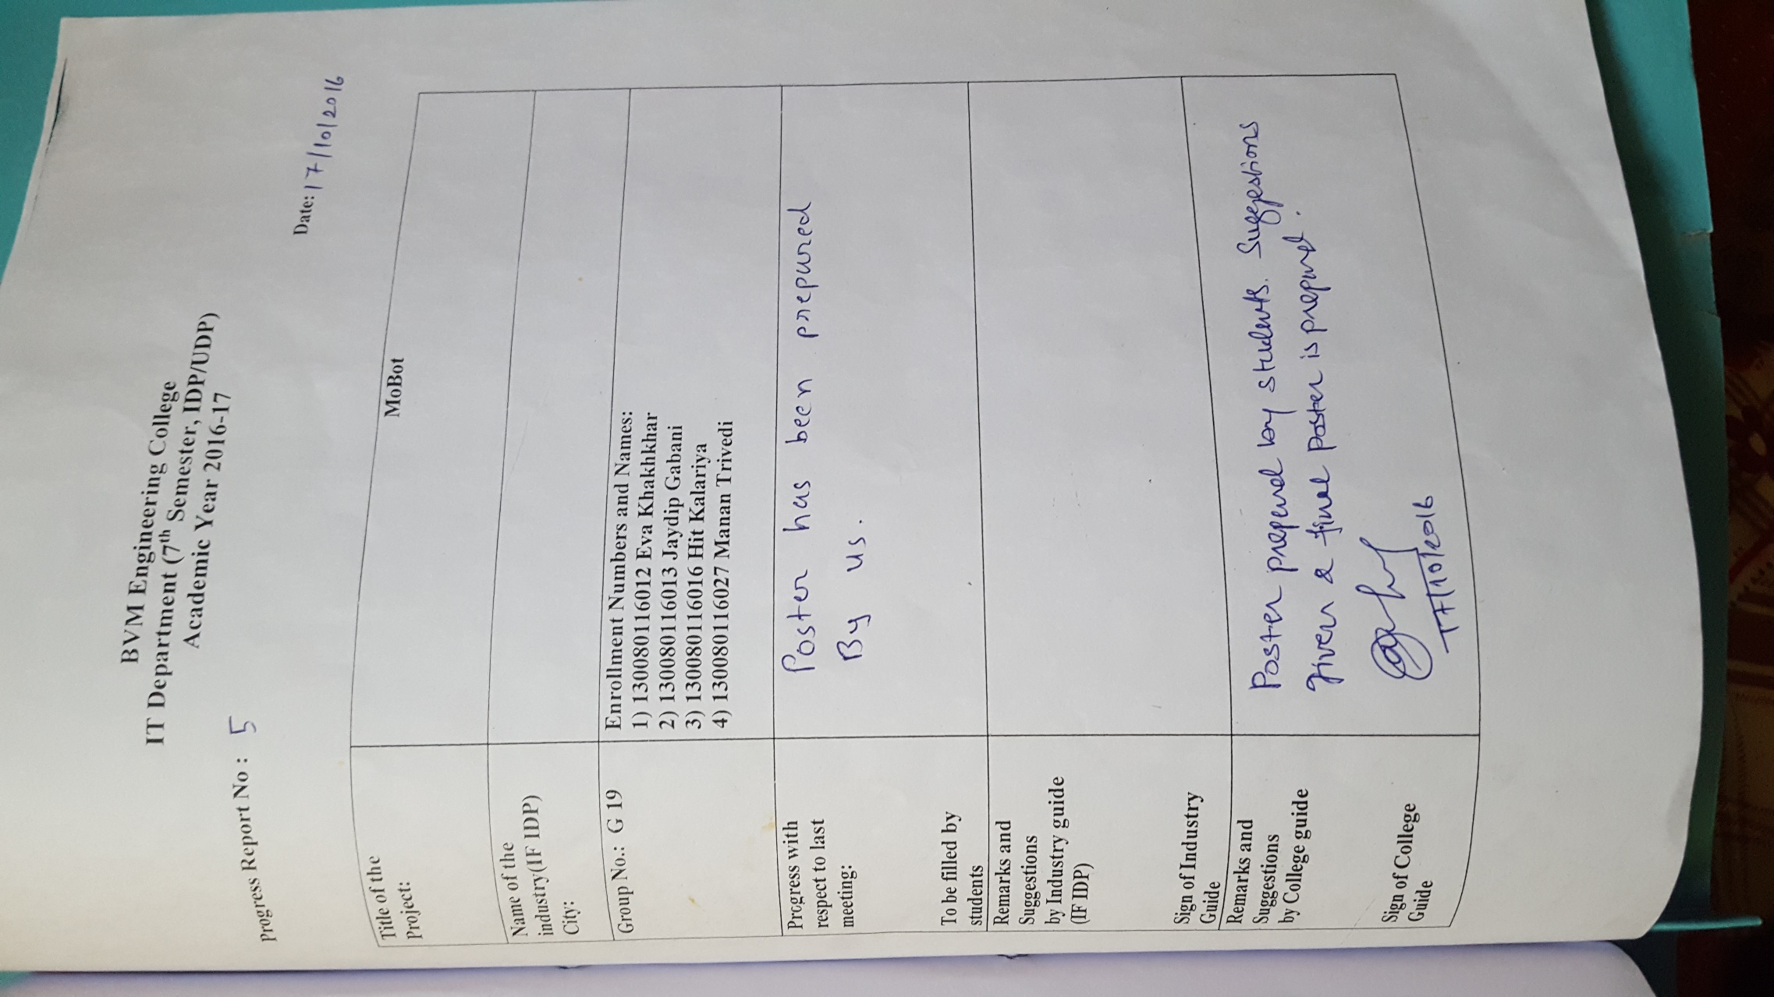

PPR 6:

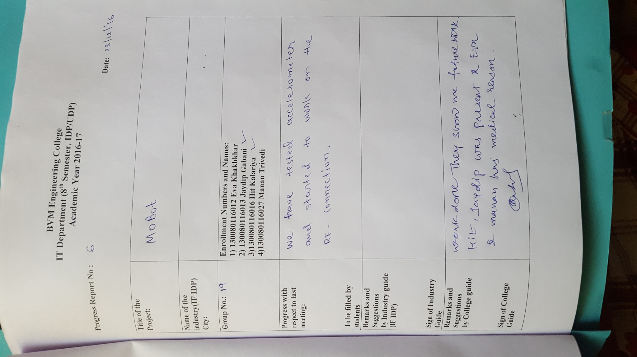

PPR 7:

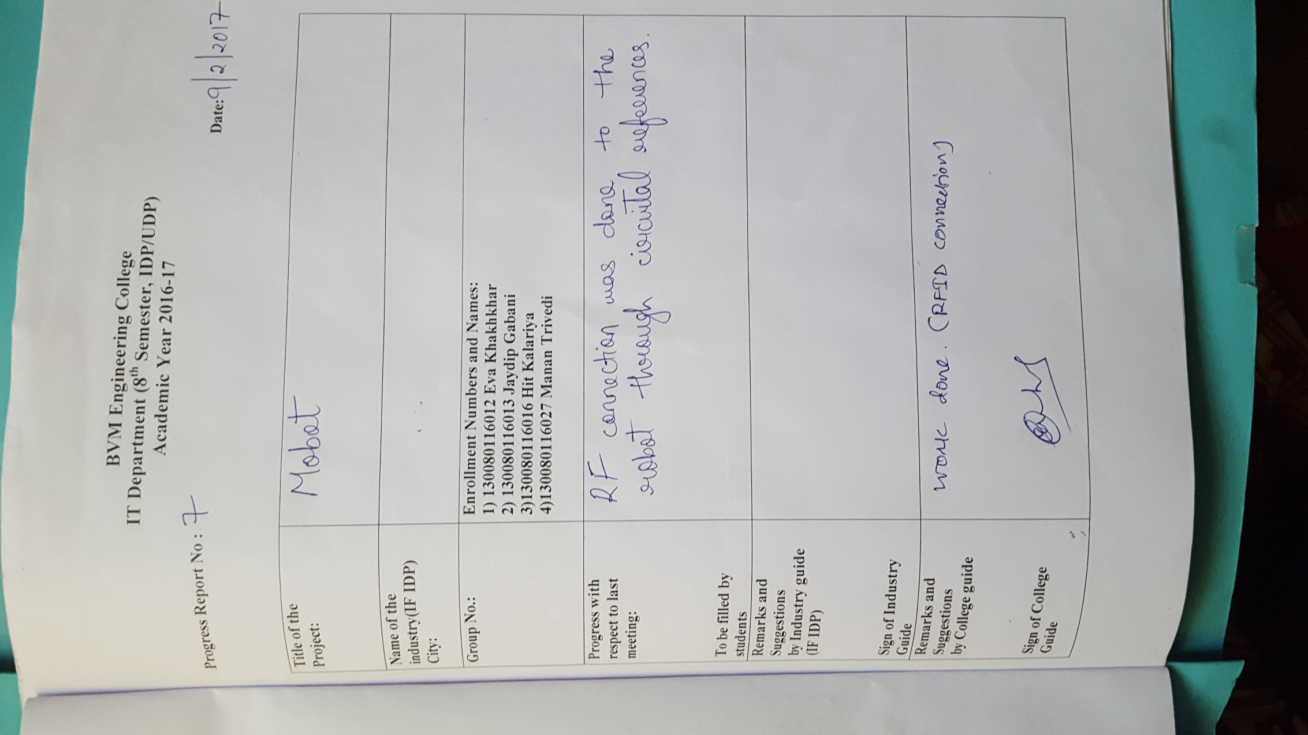

PPR 8:

